**HTML BASICS**

**HTML** stands for **Hyper Text Markup Language**. It is used for creating **web pages**.

It defines the **Structure** of the web page.

* **HTML BASIC STRUCTURE**

1. This is the basic outline of every HTML document.
2. It consists of elements.
3. An element comprises of an opening and closing tag.
4. An opening tag is denoted as <tag_name > and a closing tag is denoted as </tag_name>

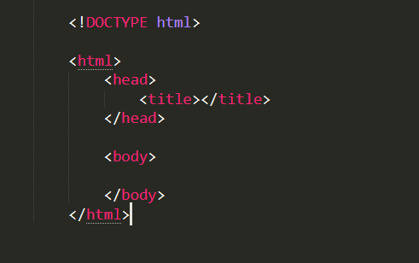

1. **<DOCTYPE html>** **:** It specifies the version or type of HTML being used to the browser.
2. **<html> :** It is the root of the entire HTML document.
3. **<head> :** It consists of all the meta - data that is the data which is informs extra information to the browser.
4. **<body> :** It consists of all the information that appears in the web page.

* **HTML ELEMENTS :**

There are two types of HTML elements :

1. **Inline elements** : An inline element does not start on a new line and it only takes up as much width as necessary.
2. **Block-level-elements** : A block-level element always starts on a new line and takes up the full width available .

